Update your user profile and create a signature

Introduction:
DocuSign is the most reliable and globally trusted service for electronic signatures and approvals. DocuSign has been selected as UC San Diego's electronic signature solution; a cloud-based application which allows users to send and sign securely for legally-enforceable (eSign compliant) digital transactions and contracts. DocuSign allows for recipient routing and business-process workflow.
Your DocuSign signature can be affixed to any document….
TIP: If you want to draw your signature with your finger, instead of using one of the canned signatures, download one of the mobile apps.
Table of Contents
Signing in to your DocuSign Account 2
From your Browser on your computer or mobile device: 2
From your Mobile device: 2
Update your profile and create a signature 2
From your Browser on your computer or mobile device: 3
Edit your profile 3
Create or edit your signature 3
From your Mobile device: 3
Edit your profile 3
Create or edit your signature 3

Signing in to your DocuSign Account

From your Browser on your computer or mobile device:
- Go to Docusign.lsit.ucsb.edu.
- Navigate to Log in to DocuSign link.
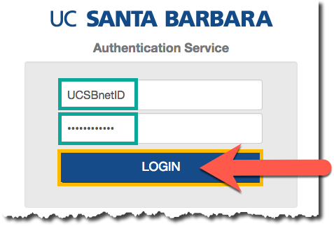
- You will be connected to UCSB SSO.
- Enter your UCSBnetID and UCSBnetID password and select Login. This will route you to your account in DocuSign.
- Once you sign-in, you'll automatically become a UCSB DS SIGNER. This allows you to view all of your signed documents and create a signature.

From your Mobile device:
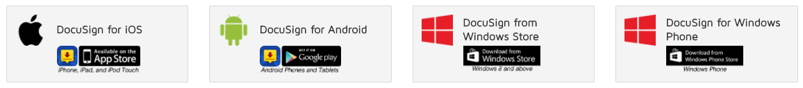
- Download one of the available mobile apps. (linked via image)
- In the app, enter your email as UCSBnetID@ucsb.edu and select Continue.
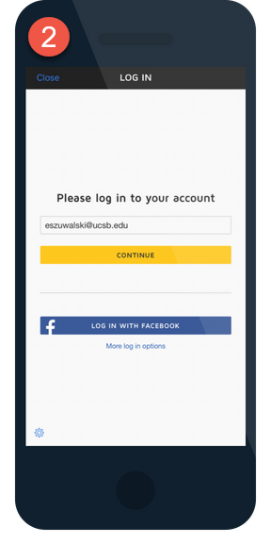
- Enter your UCSBnetID and UCSBnetID password when prompted on the screen.
UCSBnetID@ucsb.edu
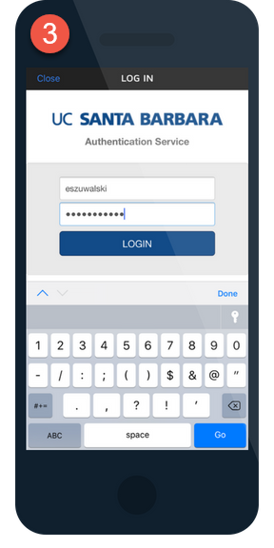
UCSBnetID
UCSBnetID password

Update your profile and create a signature

From your Browser on your computer or mobile device:

Edit your profile
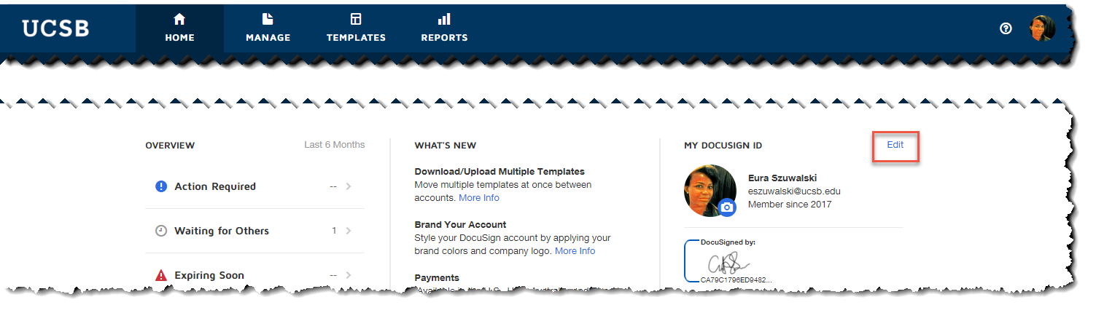
- On the DocuSign home page, select Edit link to the right of MY DOCUSIGN ID.
- From the menu on the left, select Personal Information.
- This will take you to your Identity form, enter your company and department name, job title and contact information.

Create or edit your signature
DocuSign provides several built-in options for signatures, but if you prefer you can draw your own.
- At the bottom of the Personal Information page, click on + Add New ink to create your signature.
- Verify the spelling of your name and initials.
- The Choose tab will give you all of the DocuSign provided signatures. Note: everyone’s signature has a unique code assigned to it.
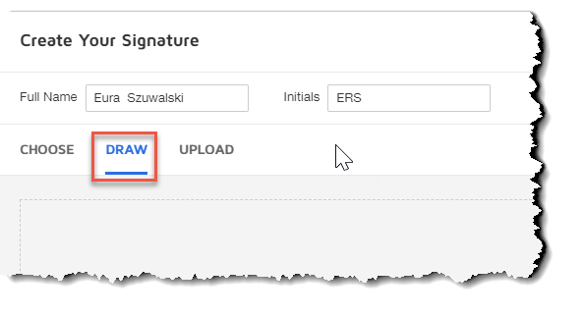
- If you want to draw your own, click on the DRAW tab link.
- Use your mouse to sign and click Create.
- Make sure you click Save at the bottom of the page to save all changes to your personal information.

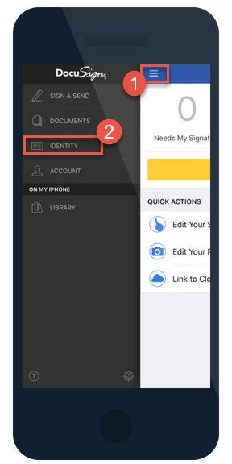
From your Mobile device:

Edit your profile
- Navigate to the menu button in the upper left corner.
- Select Identity from the list of options.
- When you are on the Identity screen, you can change your profile information and your signature. Note: The app will save as you edit the form.

Create or edit your signature and initials
You will only have the option to draw your signature and initials in the mobile app.
- If on the home screen, you can select the Edit your Signature link. Follow the prompts to draw your signature.
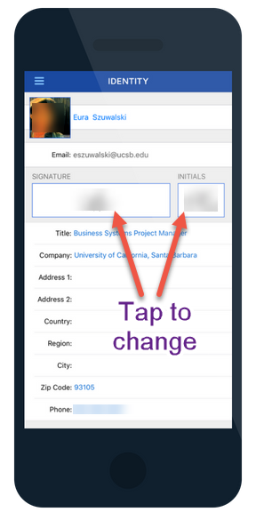
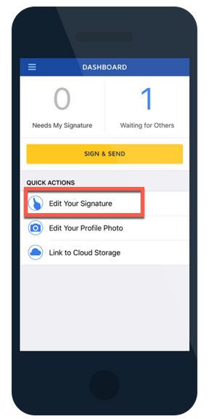
- If on the Identity screen, select the image of your signature and follow the prompts to draw a new signature.
- Repeat for the Initials image to draw your Initials.

